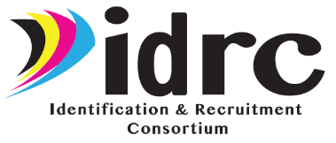
Technical Support Team (TST) Meeting
May 11, 2021 (Virtual)
8-10 PST, 9-11 MST, 10-12 CST, 11-1 EST

Participants

State Representatives:  - Arizona – Merriam Massey  - Arkansas – Not present  - Delaware – Maria Mendoza  - Idaho –Genoveva Winkler  - Illinois – Maria Dominguez  - Indiana – Josmary Pearson  - Iowa – Alex Johnson, Marcos de Mateo, Colette Stotts  - Kansas – Not present  - Kentucky – Not present  - Louisiana – Laurie Stewart  - Maine – Sean Douglas  - Michigan – Not present  - Minnesota – Cris Young, Claudia Mladek, Linda Fournier  - Mississippi – Starsha Jamerson, Maggie Villarroel  - Missouri – Ray Melecio, Matt Flaherty  - Nebraska – Danielle Waite, Ita Mendoza  - New Hampshire – Barbara Patch  - New Jersey – Not Present  - New Mexico – Bernardo Lopez  - New York – Will Messier, Yenny Díaz, Emily Callaghan  - Ohio – Gloria Altamirano  - Oregon – Merced Flores  - South Carolina – Emily Williams  - Vermont – Sara Stowell, Kelly Dolan  - Washington – Not present  - Wisconsin – Tena Torgerson, Julie Majerus | Not Present:  Alejandro Cabero (KS)  Angelica Tackett (IN)  Billie Thomas (NJ)  Bruce Lack (MI)  Carlos González (WA)  Christina Alvarez (ID)  Eric Stancell (DE)  Jamie Cunningham (AR)  Jonathan Fernow (OR)  Joram Rejouis (NJ)  Laura Puente (KY)  Marlena Gutíerrez (OH)  Michelle Mattson (MI)  Rachel Valladares (NH)  Robert Gomez (ID)  Yeni Vazquez (MO)

Consultants:
Jessica Castañeda, IDRC Project Director
Justyn Settles, IDRC Project Specialist
Cari Semivan, Evaluator, META Associates

General Updates (Jessica)

The Summer Recruitment Institute we had over 910 attendees. Evaluations showed really positive reviews. Reached over 46 different states. Really good attendance at all sessions and they are still available on the new Recruiter Learning Portal

Jessica provided an overview of the tools created from the summer institute which are included on the IDRC Recruiter Learning Portal. Items on other areas of the website are being moved to the appropriate topics in the Portal. We got some great suggestions from participants for future training topics. We will track page usage to see which pages are used the most.
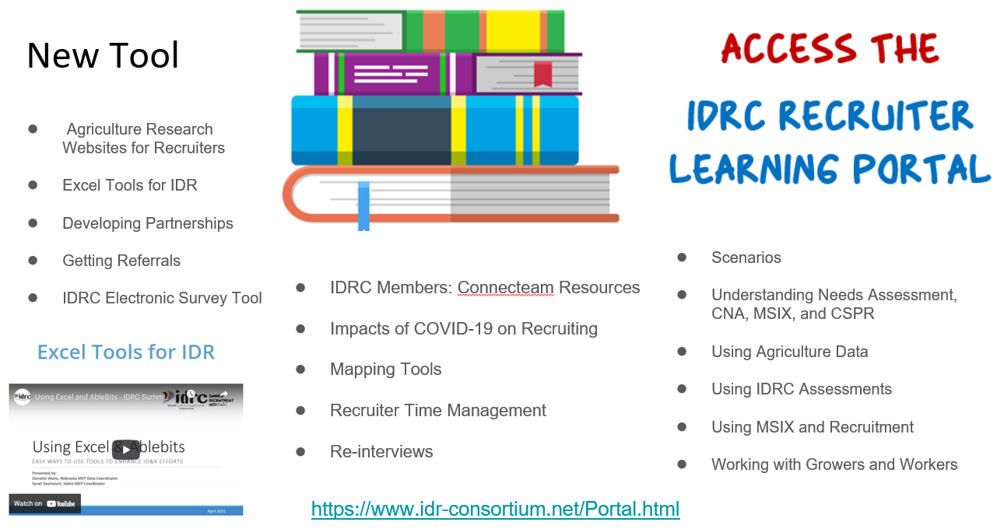

In-Person TRI Efforts
IDRC is starting in-person TRI efforts. These may involve Justyn coming and working with your state staff to replicate pilot efforts- canvassing farms and agribusinesses and general IDR in requested communities in IDRC states. In addition there is an included training component to help increase states capacity. Connecteam reporting will be used by all participants so help document the efforts of the sweep. The process to request TRI assistance is as follows.
- Fill out request form.
- Detail the areas you would like to work and at least three or more dates you would be available for the work to do.
- Number of days of the IDR effort.
- # of state staff that will be participating in the effort.
- Training needs.
- Any additional needed information for us to know about the effort.

PPE Bags and English Books
- Still offering PPE bags and English books to help with pilot efforts or to support a new IDR initiative in your state. Need to request those by filling out the request form. https://www.surveymonkey.com/r/MaterialsReq

TRI PD Trainings
- Still offering virtual TRI PD trainings. Find the listing here: https://www.idr-consortium.net/TRIteams.html

Pilot Efforts
- All states should be working on your pilot efforts. This should be either actively planning efforts, or the pilot should be underway. The pilot basically is an organized IDR sweep type effort. It should really benefit your state.

Consolidated Lists
- We will be sending to all of you your individual state list of consolidated lists from all research we did so you can have one updated master list.

TST Workgroup Updates (Jessica and Justyn)

Recruiter Training Workgroup

- The Recruiter Training workgroup reviewed topics for the Recruiting 101 Module and confirmed assignments within the workgroup.
- To date, the first module has been created (What makes a Great Recruiter"). The team has approved the look and design.

Recruiter Training 101 Modules
1. What Makes a Good Recruiter
2. Resources Available to Recruiters
3. The Migratory Agricultural Worker
4. The Qualifying Move
5. Getting Familiar With the COE
6. Getting Out Into the Field
7. After Being in the Field

- All 7 modules will be complete and ready to pilot by the end of the month (May 2021).
- The Recruiter Training 101 lesson will first focus on self-study and allowing recruiters to review the information and lessons on their own and in their own time. To help facilitate the self-study, the Recruiter Training 101 will include a downloadable workbook that recruiters can use to guide their learning. The workbook will include:
- learning objectives for each module;
- summary of material;
- resources for further reading/learning;
- link to a mini quiz for each module to gauge retention of information;
- questions for self-reflection; and
- space for supervisor to sign off on completion.
- Goal is to have the presentations complete within the next couple of weeks, approved by the workgroup, then it will be distributed to the states this summer to pilot test.
- How long will it take for a new recruiter to take each module? Modules will be around 20 minutes each, with the max being 30 minutes.

Coordinators Training Workgroup

- The group will be hosting a Networking Session for IDR Coordinators/and Recruiter Supervisors on May 27 on Motivating Recruiters. On July 15, they will be hosting one on Documenting Processes. Each session is designed to allow coordinators/supervisors to share challenges, ideas, strategies, etc. with others and build a network of people they can reach out to with questions.
- By September, we will have a module for coordinators/supervisors on how to determine if non-traditional qualifying activities qualify and building a module on how to do this. What might be some non-traditional things that people have seen in the past where families actually do qualify.

Mapping Tool Workgroup

- No new tasks for this group were identified as all FII requirements have been met, just making sure we were on track.
- Spent time talking about the pilot and how BatchGeo was working for states.
- Reviewed some of the usage data and discussed new compiled lists.
- Discussed pros and cons of BatchGeo.

Recruiter Assessment Workgroup

- Results so far of the new Recruiter Skills Competency Assessment are shown below. About 40 people have taken the assessment to date. Would like to have more than 50. Want to make sure that the assessment is at a level where even experienced recruiters can increase their knowledge. Most people are passing the first time they complete the assessment. A few people that have taken did not pass on their first attempt.
    - Average score: 83.3% (passing is considered 80%)
    - Average questions correct: 33/40
    - Average Completion Time: 55 minutes
- The workgroup looked at the statistics and reviewed the 12 most missed questions on the assessment to see why questions were being missed and if any questions needed to be improved. Of the questions reviewed, only one question needed an adjustment.

Assessment lessons learned:
- Several questions missed resulted from test takers making assumptions instead of reading the question thoroughly.
- Most common questions missed related to subsequent qualifying moves when the Migratory Agricultural Worker is no longer performing agricultural work.
- The assessment is doing a good job of highlighting the areas for additional training.

Next Steps:
- The workgroup will review the remaining questions this week to see if any adjustments need to be made.
- Continue working on new monthly mini quizzes. New mini quiz by the 15th of each month.
- The group has talked about translating the assessment into Spanish to increase accessibility for all recruiters to the assessment.

Data Reconciliation Workgroup

- Worked on a CSPR Timeline Document.
- Went through each CSPR file and determined the source of information and where it could be gathered from as well as when it should be gathered. This document will be completed this month (May). Training provided on the CSPR Timeline Document and the Residency Verification Processes.
- Limit one representative per state
- We would like to do this in July via Zoom for an hour and a half.
- Send invite ahead of time enough to allow states to send questions that may be able to be addressed during the session.
- Also talked about some of the limitations to MIS2000. Began discussions about future conversations to learn how others are using their data tools to build upon, instead of being so separate.

Upcoming IDRC Training:

Date | Time | Title/Topic
May 11 | 2:00-3:00p EST | IDRC Monthly Webinar – How to Organize and Prioritize Your Data
May 27 | 2:00-3:00p EST | IDR Coordinators/Recruiter Supervisors Networking Meeting
June 8 | 2:00-3:00p EST | IDRC Monthly Webinar – Recruiter 101
July 6 | 2:00-3:00p EST | IDRC Monthly Webinar – Recruiter Safety Course
July 15 | 2:00-3:00p EST | IDR Coordinators/Recruiter Supervisors Networking Meeting

